

**GROUP ASSIGNMENT – Part 2**

**TECHNOLOGY PARK MALAYSIA**

**CT042-3-1-IDB**

**INTRODUCTION TO DATABASE**

APD1F2011CS/CS(CYB)/CS(IS)/IT/SE

APU1F2011CS/CS(CYB)/CS(IS)/CS(DF)/IT/SE

**HAND OUT DATE: 18 JUNE 2021**

**HAND IN DATE: 20 AUGUST 2021**

**WEIGHTAGE: 60%**

**LECTURER: Ts. Dr. Shubashini Rathina Velu**

**INSTRUCTIONS TO CANDIDATES:**

**1 Submit your assignment at the administrative counter.**

**2 Students are advised to underpin their answers with the use of references (cited using the Harvard Name System of Referencing).**

**3 Late submission will be awarded zero (0) unless Extenuating Circumstances (EC) are upheld.**

**4 Cases of plagiarism will be penalized.**

**5 The assignment should be bound in an appropriate style (comb bound or stapled).**

**6 Where the assignment should be submitted in both hardcopy and softcopy, the softcopy of the written assignment and source code (where appropriate) should be on a CD in an envelope / CD cover and attached to the hardcopy.**

**7 You must obtain 50% overall to pass this module.**

**GROUP MEMBERS:**

|  |  |  |
| --- | --- | --- |
|  | **NAME** | **TP Number** |
| **G. Leader** | **ESLAM MAGDY REZK EBRAHIM HASSANIN** | **TP062816** |
| **Member** | **SEITKEREY DINMUKHAMED** | **TP057390** |
| **Member** | **MWENGU MUSENGE** | **TP062172** |

Table of Contents

Database schema: 4

Individual component: 5

1. SQL-Data Definition Language (DDL): 5

2. SQL-Data Manipulation Language (DML): 10

References 18

CT042-3-1 Database Systems – Workload Matrix 19

**Table of figures:**

Figure 1: DBMS Diagram 5

Figure 2:SQL-Data Definition Language(DDL) 8

Figure 3:Insert values into all tables (MEPGS) 8

Figure 4:Insert values into all tables (MEPGS) 9

Figure 5: Q (I) 10

Figure 6: Q I Output 10

Figure 7: Q (V) 11

Figure 8: Q (V) Output 11

Figure 9: Q (VIII) 12

Figure 10: Q (VIII) Output 12

Figure 11: Q(III) 12

Figure 12: Q(III) Output 12

Figure 13: Question (X) 13

Figure 14: Question (X) Output 13

Figure 15: Question (VII) 14

Figure 16: Question (VII) Output 14

Figure 17: Question (IX) 15

Figure 18: Question (IX) Output 15

Figure 19: Question (II) 16

Figure 20: Question (II) Output 16

Figure 21:Question (IV) 17

Figure 22: Question (IV) Output 17

Figure 23: Solution 2 17

Figure 24: Solution 2 Output 17

# **Database schema:**

This is a tool within the database designer program, such as what is found in Microsoft and is called the Database diagram, which is when you finish designing your database, you can design its own tables, columns, index and keys, and be in the form of a diagram to show the relationships between each table and the other Define the primary and foreign key (Microsoft, 2017).

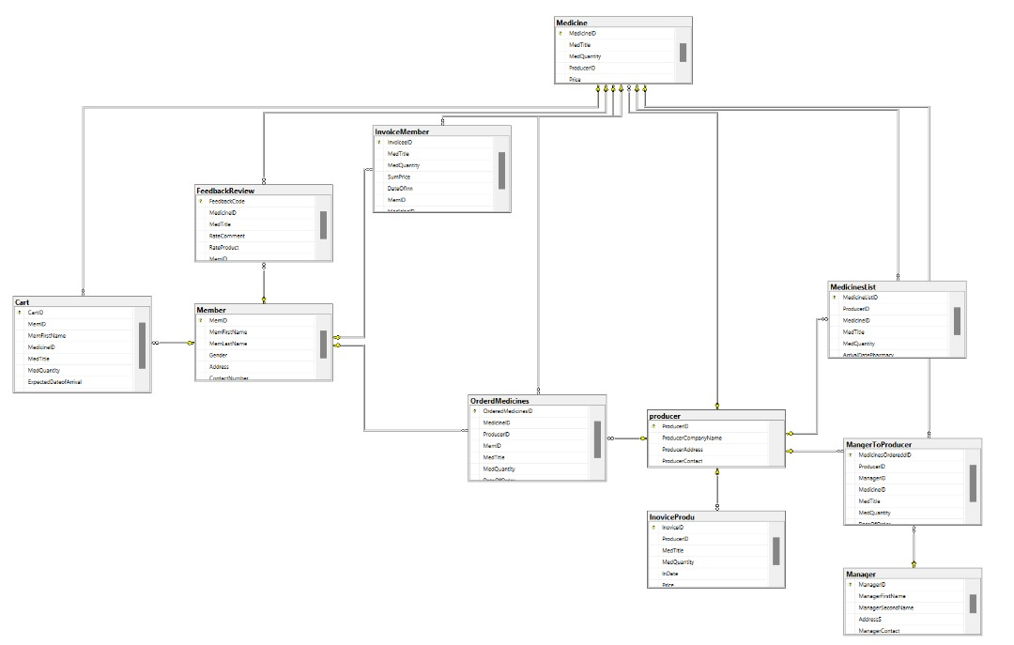

Figure 1: DBMS Diagram

# **Individual component:**

## **SQL-Data Definition Language (DDL):**

It is a language used to modify and structure data and is mainly used in creating tables, Including the “Create command”, which is used to make tables, the second thing it contains is “Drop command” and it is used to update tables, click or remove the entire database, The third thing, which is the Alter command, is used to modify or remove columns or change a database object. It takes care of the database structure and modifies it, The fourth thing, which is the Rename command, is usually used to change the names of the tables within the database, The fifth and final thing, which is the Truncate command, is concerned with removing the rows and spaces allocated to the records. It is like a delete command, but the difference between them is that the delete command is for the user to retrieve the data at a later time, but that is very difficult (tutorialride, n.d.).

|  |  |
| --- | --- |
| **Function** | **SQL-Data Definition Language Statements** |
| **Create table producers** |  |
| **Create table Member** |  |
| **Create table Medicine** |  |
| **Create table MedicinesList** |  |
| **Create table Manager** |  |
| **Create table MangerToProducer** |  |
| **Create table Cart** |  |
| **Create table InoviceMem** |  |
| **Create table FeedbackReview** |  |
| **Create table OrderedMedicines** |  |
| **Create table InovoiceMember** |  |

Figure 2:SQL-Data Definition Language(DDL)

**Insert Values into tables:**

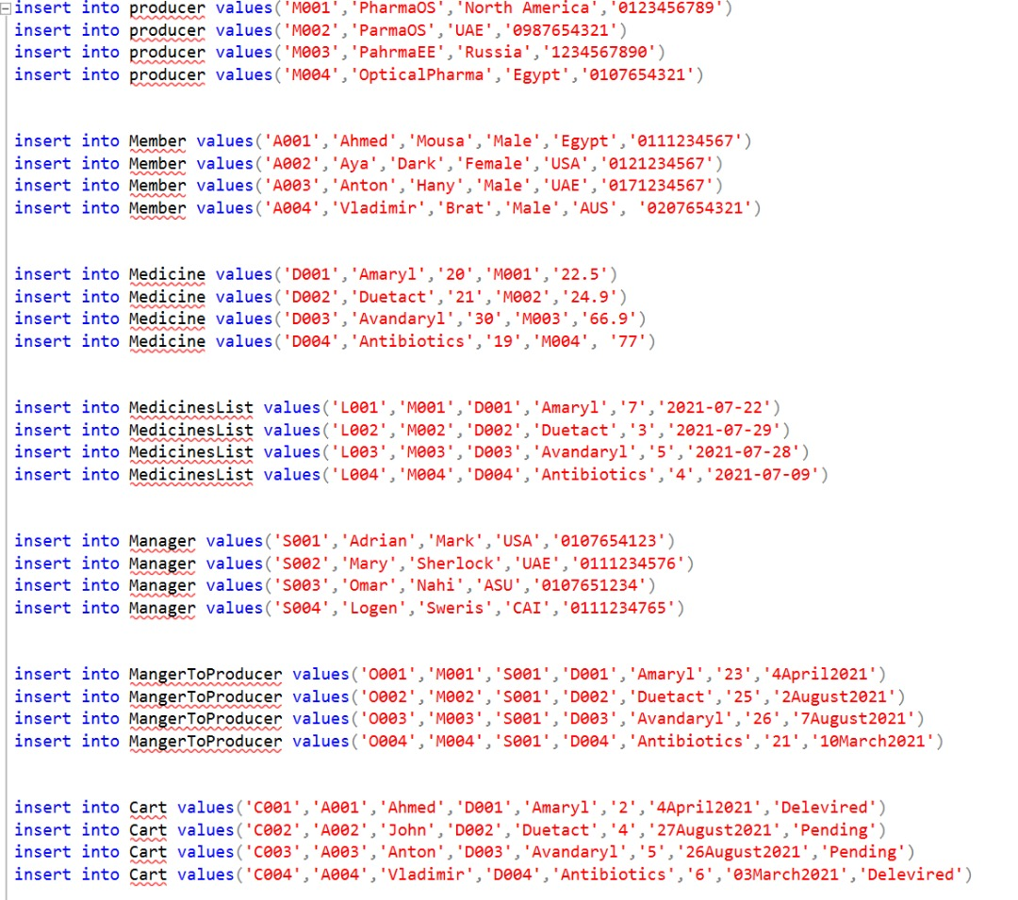

Figure 3:Insert values into all tables (MEPGS)

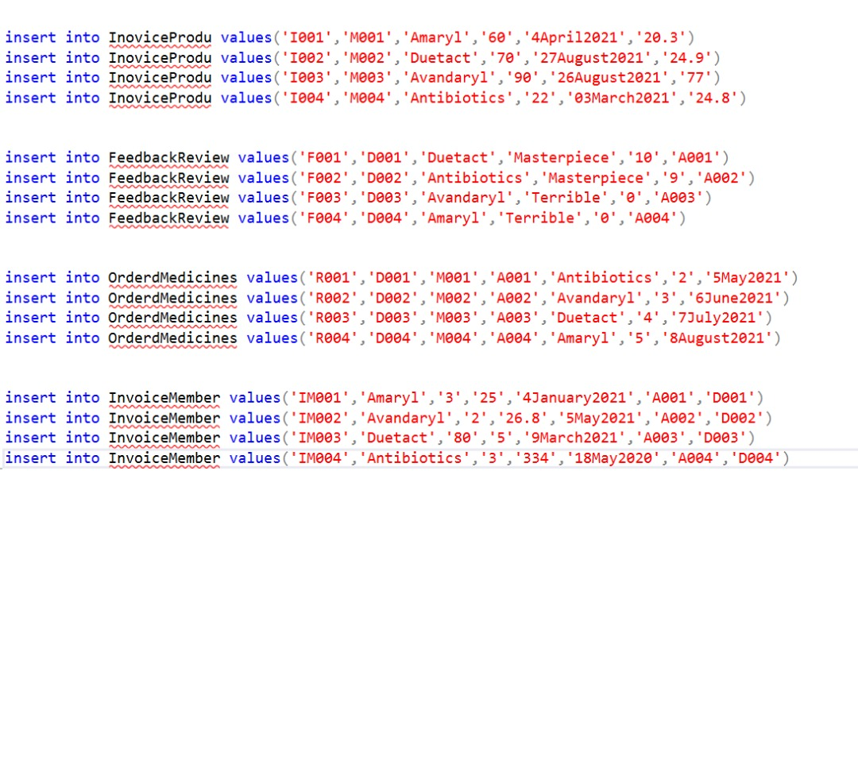

Figure 4:Insert values into all tables (MEPGS)

## **SQL-Data Manipulation Language (DML):**

Data Manipulationlanguage is the language of a variety of computer languages ​​and allows the programmer to play in databases by inserting, scanning, updating, etc. It is always integrated and run with SQL, so its including select command is used to retrieve the rows that are inside the table, and there is also an update or modification command, as it can modify more than one record at the same time, and also the insert command, which can enter more than one record at the same time, and also Delete command that can delete and remove more than one record at the same time (techopedia, 2014).

**Seitkerey Dinmukhamed(TP057390):**

List the medicine(s) or item(s) which has the highest rating. Show medicine id, medicine name, and the rating.

Query:

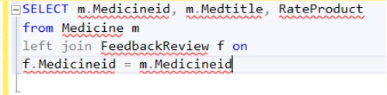

Figure 5: Q (I)

Output:

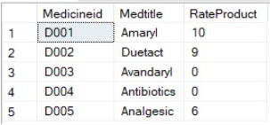

Figure 6: Q I Output

**V.**

Find the total number of medicines or items ordered by each member.

Query:

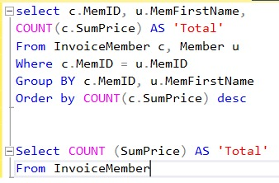

Figure 7: Q (V)

Output:

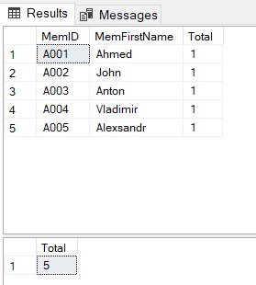

Figure 8: Q (V) Output

**Eslam Magdy Rezk Ebrahim Hassanin(TP062816):**

**VIII.**

Query Statement:

Show a list of purchased medicines and other items that have not been delivered to members. The list should show member identification number, address, contact number, medicine or item serial number, medicine/ item name, quantity, date and status of delivery.

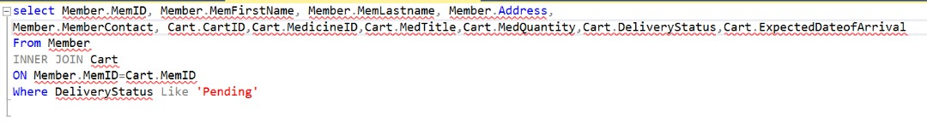

Figure 9: Q (VIII)

Output:

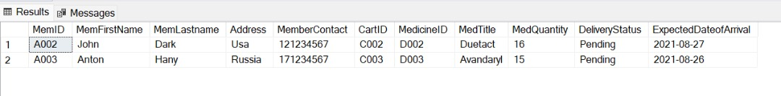

Figure 10: Q (VIII) Output

**III.**

Find the detail of medicine or essential item producer. Show producer id, producer name, address and contact number.

Query Statement:

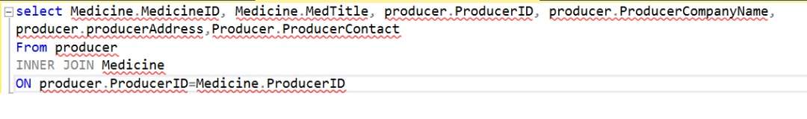

Figure 11: Q(III)

**Output:**

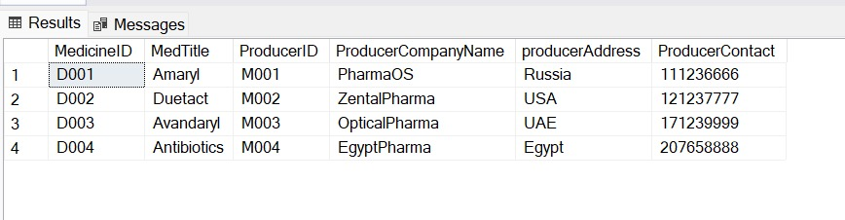

Figure 12: Q(III) Output

**X.**

Show a list of total medicines / items as added by each members in the shopping cart.

Query statement:

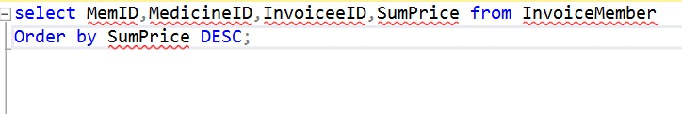

Figure 13: Question (X)

Output:

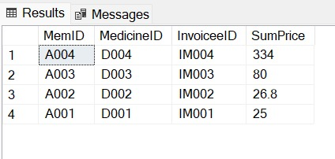

Figure 14: Question (X) Output

**VII.**

Show list of total customers based on gender who are registered as members in Malaysia’s E Pharmacy and General Store. The list should show total number of registered members and total number of gender (male and female).

Query statement:

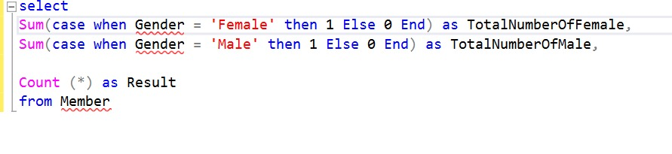

Figure 15: Question (VII)

Output:

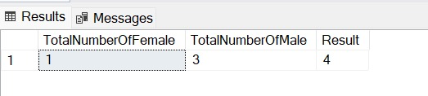

Figure 16: Question (VII) Output

**IX.**

Show the member who spent most on buying medicines/ items. Show member id, member name and total expenditure.

Query statement:

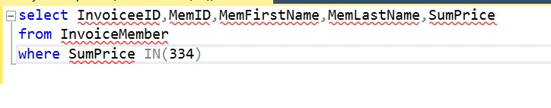

Figure 17: Question (IX)

Output:

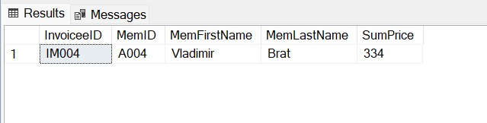

Figure 18: Question (IX) Output

**Mwengu Musengu(TP062172):**

**II.**

find the number of feedbacks per member. Show member id , member name and total number of feedback per me

Query statement:

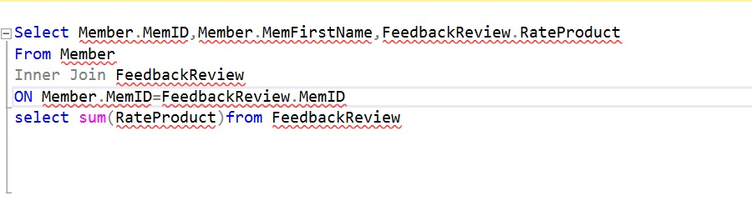

Figure 19: Question (II)

Result

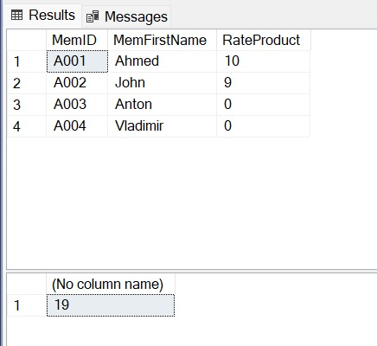

Figure 20: Question (II) Output

**IV.**

find the total number of medicines or items ordered by each member:

Query statement:

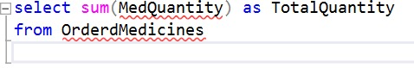

Figure 21:Question (IV)

Output:

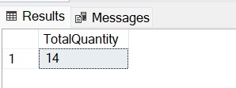

Figure 22: Question (IV) Output

Query statement:

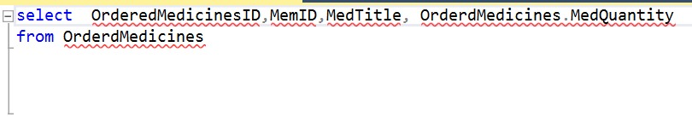

Figure 23: Solution 2

Output:

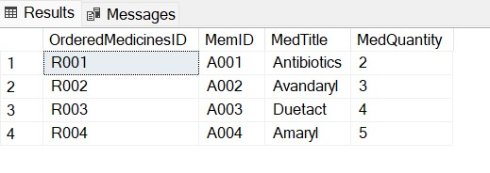

Figure 24: Solution 2 Output

# **References**

Microsoft, 2017. *Design Database Diagrams (Visual Database Tools).* [Online]   
Available at: https://docs.microsoft.com/en-us/sql/ssms/visual-db-tools/design-database-diagrams-visual-database-tools?view=sql-server-ver15  
[Accessed 2021 08 20].

tutorialride, n.d. *SQL Data Definition Language (DDL).* [Online]   
Available at: https://www.tutorialride.com/dbms/sql-data-definition-language-ddl.htm  
[Accessed 20 08 2021].

# **CT042-3-1 Database Systems – Workload Matrix**

|  |  |  |  |  |  |
| --- | --- | --- | --- | --- | --- |
| **Part** | **Component** | **Student 1 Name:** Eslam Magdy Rezk Ebrahim Hassanin  **TPNumber:**  TP062816 | **Student2 Name:** Seitkerey Dinmukhamed  **TPNumber:**  TP057390 | **Student 3 Name:** Mwengu Musengu  **TPNumber:** TP062172 | **Total** |
| 2 | Database schema | 33.33 | 33.33 | 33.33 | **100%** |
| 2 | DDL – Individual component(Producer – Member – MedicineID) | - | - | 100% | **100%** |
| 2 | DDL–Individual components(MedicinesList– Manager-ManagerToProducer)Tables | - | 100 % | - | **100%** |
| 2 | DDL–Individual Component(Cart –noviceProdu-Feedbackreview-OrderedMedicines-InvoiceMember) Tables | 100 % | - | - | **100%** |
| 2 | DML  II – IV Queries | - | - | 100 % | **100%** |
| 2 | DML  I – V Queries | - | 100 % | - | **100%** |
| 2 | DML  IX – VII – X – III – VII Queries | 100 % | - | - | **100%** |
| **Signature** | |  |  |  | |